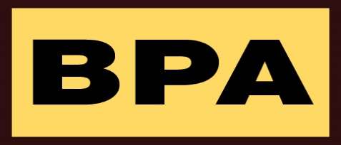

GS-07F-BA14

Blanket Purchase Agreement (BPA) Number GS-07F-BA014, Federal Supply Class 4240, Particulate Respirator, has been awarded to Louis M. Gerson Co. Inc. General Services Administration (GSA) has carefully determined both on price and best value so we can provide other federal agencies with this commodity.